**Lab 3**

**1. First Come, First Served (FCFS)**

FCFS is an operating system scheduling algorithm that automatically executes queued requests and processes by order of their arrival.

It supports non-preemptive and pre-emptive scheduling. So after the process has been allocated to the CPU, it will never release the CPU until it finishes executing.

A real-life example of the FCFS method is buying a movie ticket on the ticket counter.

**Algorithm**

* Take an array of the processes
* Find the ‘gaint chart’ from the processes by adding the previous process time one after another
* Finally calculate the waiting time from the ‘gaint chart’ by adding all the values from the ‘gaint chart’ array except the last one and divide by the number of processes.

|  |  |
| --- | --- |
| #! /bin/bash  cpuBt=(24 3 4)  echo "The CPU Burst Time is-------"  echo ${cpuBt[*]}  #Finding the gaint chart  temp=0  j=0  for i in ${cpuBt[@]}  do  temp=$((temp+i))  gaintc[$j]=$temp  j=$((j+1))  done | echo "The Gaint Chart is-------"  echo ${gaintc[*]}  #Finding the waiting Time  sum=0  for ((i=0;i<${#gaintc[@]}-1;i++))  do  temp=${gaintc[$i]}  sum=$((sum+temp))  done  WT=$(bc -l <<< "scale=3;$sum/$j")  echo "The Waiting Time is--------------"  echo $WT |

**Code**

**Output**

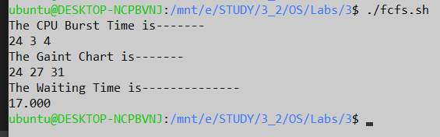

**2. Shortest Job First (SJF)**

Shortest job first is a scheduling algorithm in which the process with the smallest execution time is selected for execution next. Shortest job first can be either preemptive or non-preemptive.

**Algorithm**

* Take an array of the processes
* Sort the array
* Find the ‘gaint chart’ from the processes by adding the previous process time one after another.
* Finally calculate the waiting time from the ‘gaint chart’ by adding all the values from the ‘gaint chart’ array except the last one and divide by the number of processes.

**Code**

|  |  |
| --- | --- |
| #FOR SJF  cpuBt2=(24 3 4)  echo "Befor Sorting"  echo ${cpuBt2[*]}  #Sorting (Bubble)  for ((i=0;i<4;i++))  do  for ((k=0;k<4-i-1;k++))  do  if [ ${cpuBt2[k]} -gt ${cpuBt2[$((k+1))]} ]  then  #swap  temp=${cpuBt2[k]}  cpuBt2[$k]=${cpuBt2[$((k+1))]}  cpuBt2[$((k+1))]=$temp  fi  done  done  echo "After Sorting"  echo ${cpuBt2[*]} | #NOW APPLY SCSF ALGO ON CPUBT2  #Gaint CHART  temp=0  j=0  for i in ${cpuBt2[@]}  do  temp=$((temp+i))  gaintc[$j]=$temp  j=$((j+1))  done  echo "Gaint CHart"  echo ${gaintc[@]}  #Finding the waiting Time  sum=0  for ((i=0;i<${#gaintc[@]}-1;i++))  do  temp=${gaintc[$i]}  sum=$((sum+temp))  done  WT=$(bc -l <<< "scale=3;$sum/$j")  echo "Waiting Time is--------"  echo $WT |

**Output**

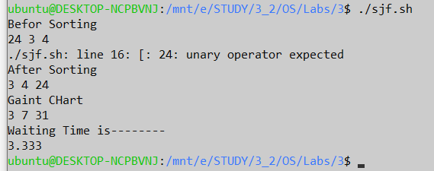

**Discussions**

In this lab, we learned two basic CPU scheduling algorithm. The processes were taken into a static array. But it can be done by taking input from the user easily. For better comfort I had taken it in a static array. By observing the two algorithms, it can be seen that Shortest time first scheduling algorithm is more convenient than the FCFS algorithm.